AWS IAM TASKS

Tasks
1. Create one IAM user and assign EC2 and S3 full access.
2. Create one group in IAM and assign read access for EC2.
3. Create a new user named “Devops” and add to the group created in Task 2.
4. Write a bash script to create an IAM user with VPC full access.
5. Create an IAM policy to allow EC2 access for a specific user in specific regions only.
6. Cross-account access: Account A user should access an S3 bucket in Account B.

Prerequisites
- An AWS account with an IAM user/role that has administrative or IAM-management permissions (e.g., IAMFullAccess).
- AWS Management Console access.
- AWS CLI v2 installed and configured (aws configure) for Task 4 — with credentials that have iam:CreateUser, iam:AttachUserPolicy, iam:CreateAccessKey permissions.
- For Task 6, access to two AWS accounts (Account A and Account B) — you can use a second account of your own, or collaborate with a friend/colleague who owns Account B.

TASK 1: Create an IAM User with EC2 and S3 Full Access

Step 1.1 — Open the IAM Console
1. Log in to the AWS Management Console.
2. In the top search bar, type IAM and click IAM (under Services).
3. IAM is a global service — no region selection is needed.
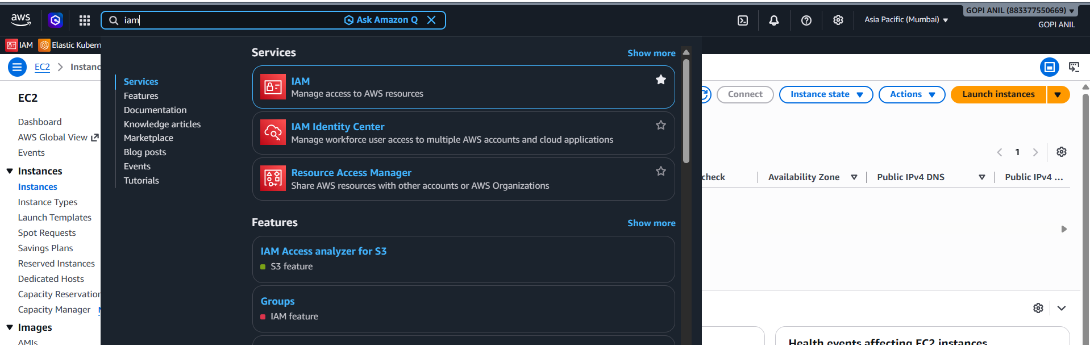

Step 1.2 — Create the User
1. Left pane → Users → Create user.
2. User name: ec2-s3-admin.
3. Leave “Provide user access to the AWS Management Console” unchecked unless console sign-in is required; check it and set a password if needed. Click Next.
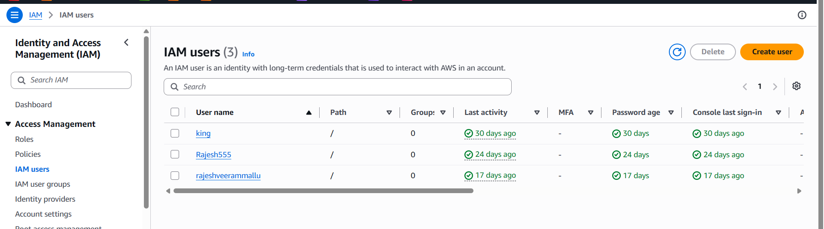
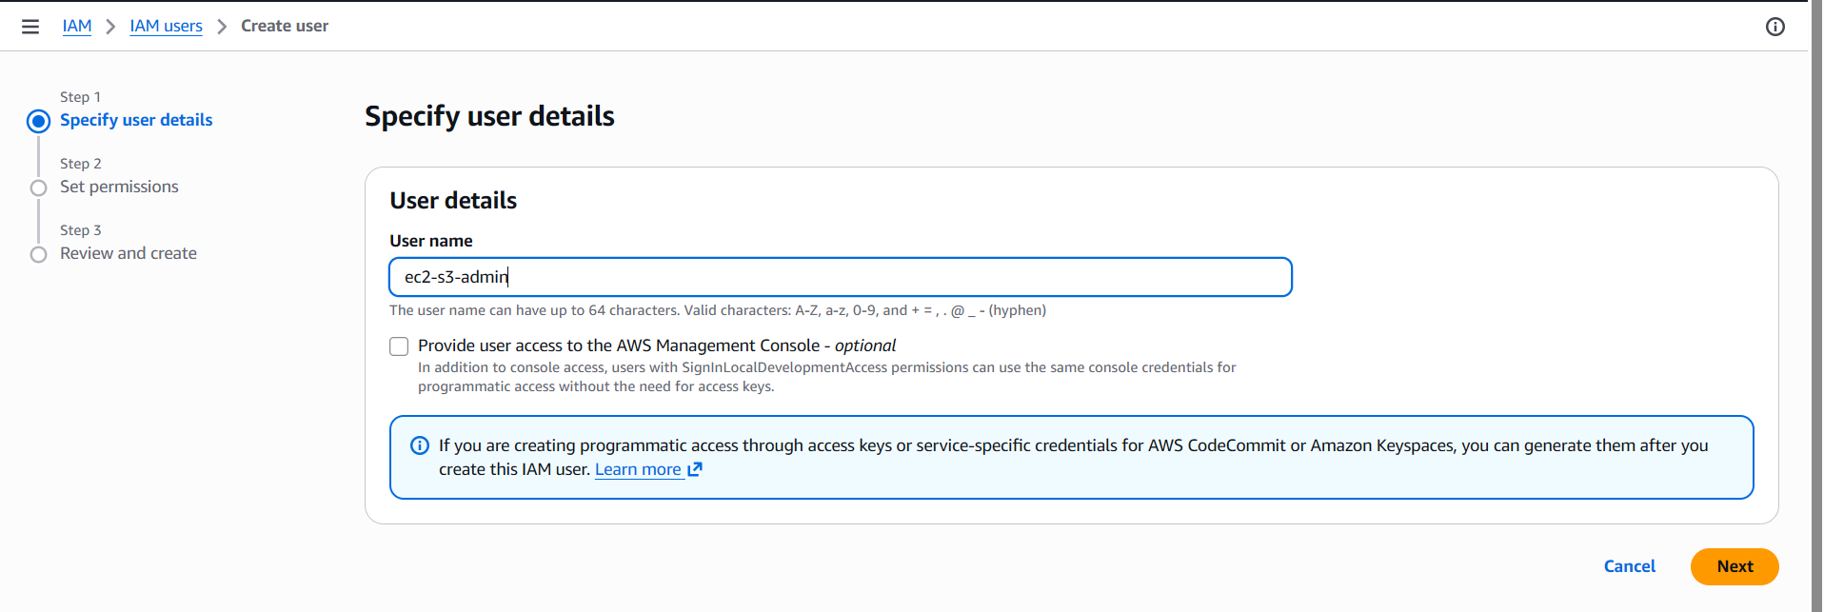

Step 1.3 — Attach Permissions
1. On the “Set permissions” page, select Attach policies directly.
2. In the search box, type EC2FullAccess → check the box next to AmazonEC2FullAccess.
3. In the search box, type S3FullAccess → check the box next to AmazonS3FullAccess.
4. Click Next.
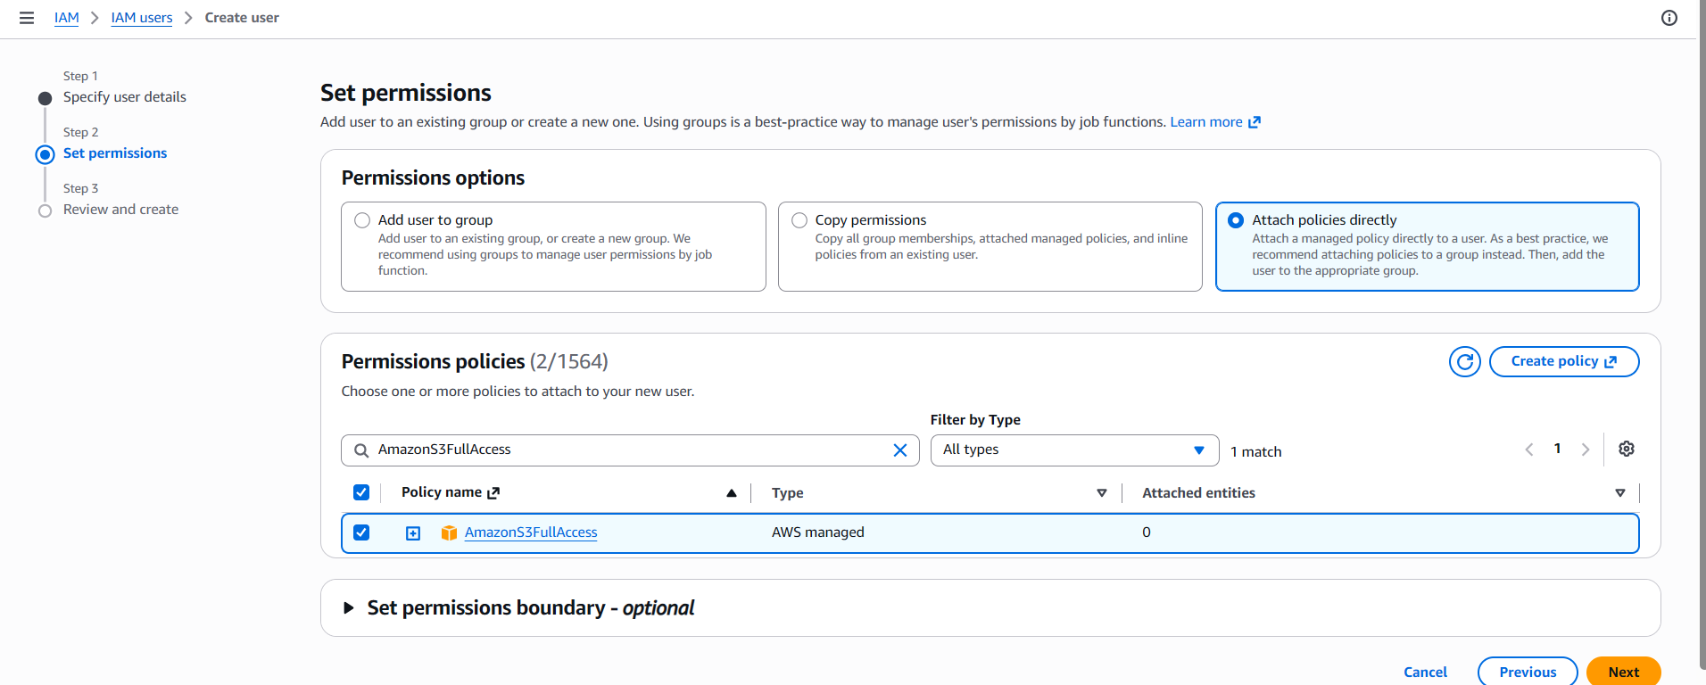

Step 1.4 — Review and Create
1. Review the user name and the two attached policies (AmazonEC2FullAccess, AmazonS3FullAccess).
2. Click Create user.
3. On the success screen, note the user ARN. If you enabled console access, download the .csv with the sign-in credentials — this is shown only once.
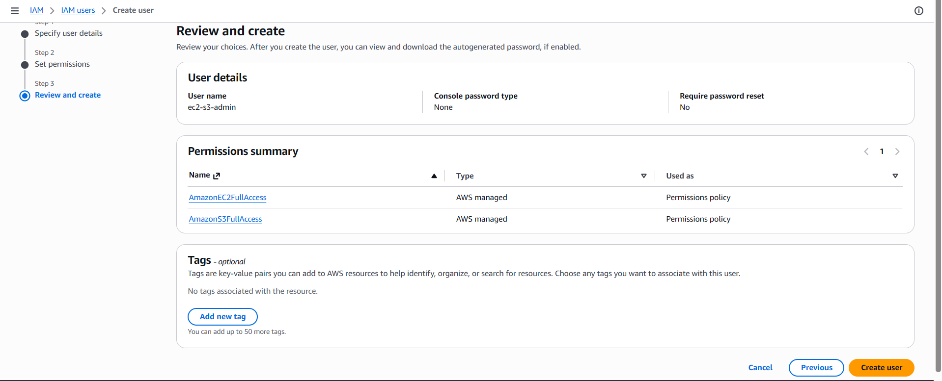

Step 1.5 — Verify
1. Left pane → Users → click ec2-s3-admin.
2. Permissions tab → confirm both AmazonEC2FullAccess and AmazonS3FullAccess are listed under “Permissions policies.”
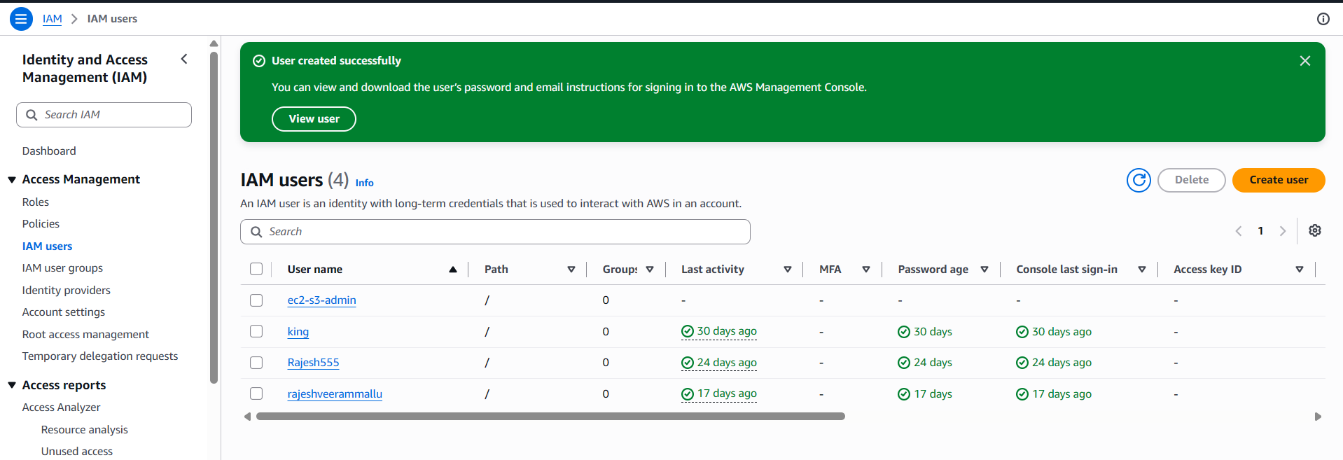
✅ Task 1 Complete: IAM user ec2-s3-admin has full access to both EC2 and S3.

TASK 2: Create an IAM Group with EC2 Read Access

Step 2.1 — Open the Groups Section
- IAM Console → left pane → User groups → Create group.
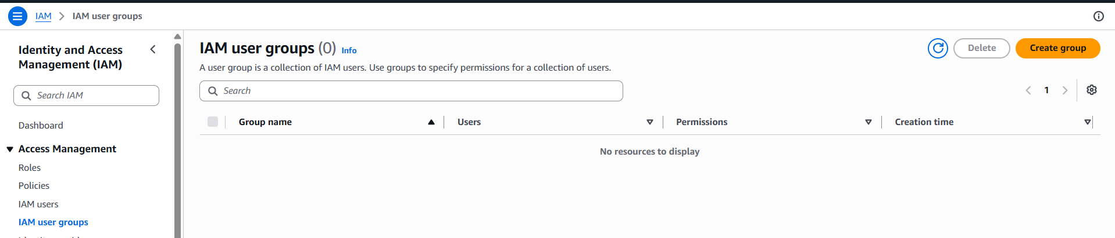

Step 2.2 — Configure the Group
1. User group name: EC2-ReadOnly-Group.
2. Under “Attach permissions policies,” search for EC2ReadOnly → check the box next to AmazonEC2ReadOnlyAccess.
3. (Do not add users yet — Task 3 will add the Devops user to this group.)
4. Click Create group.
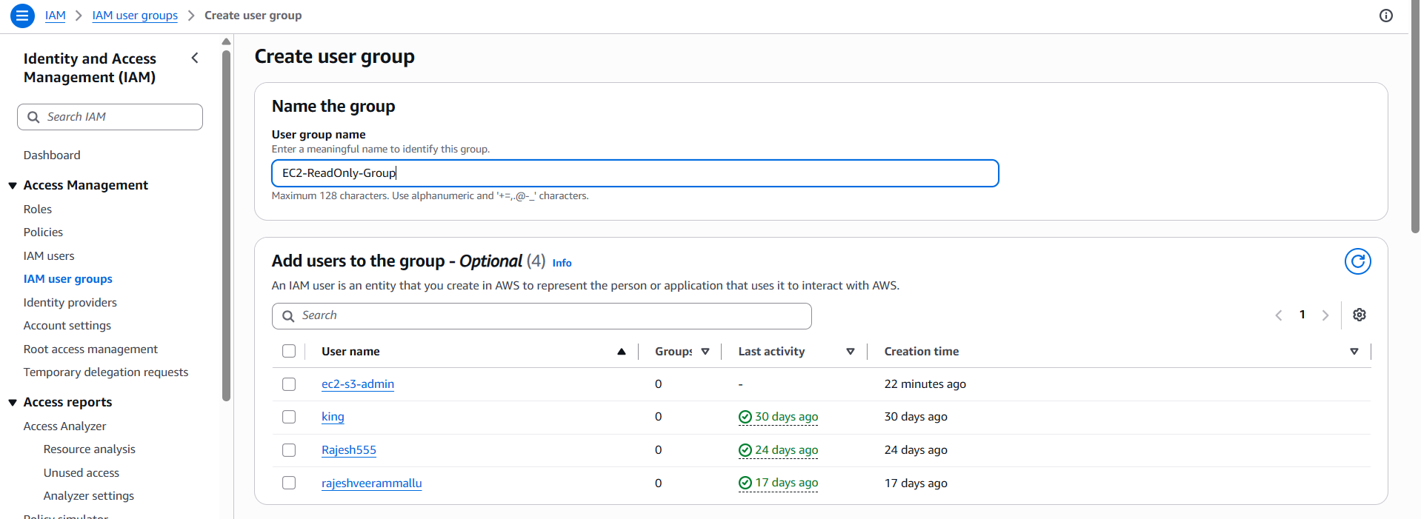
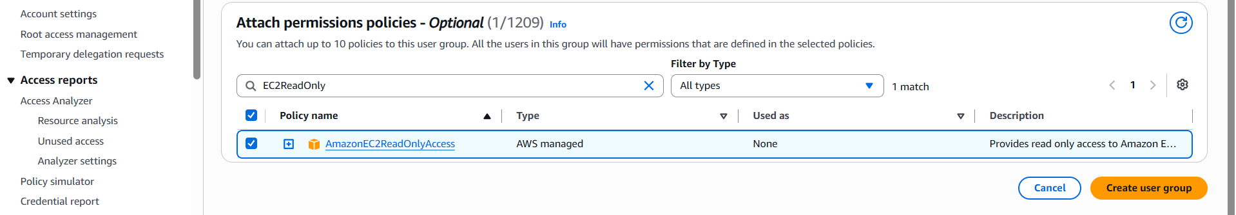
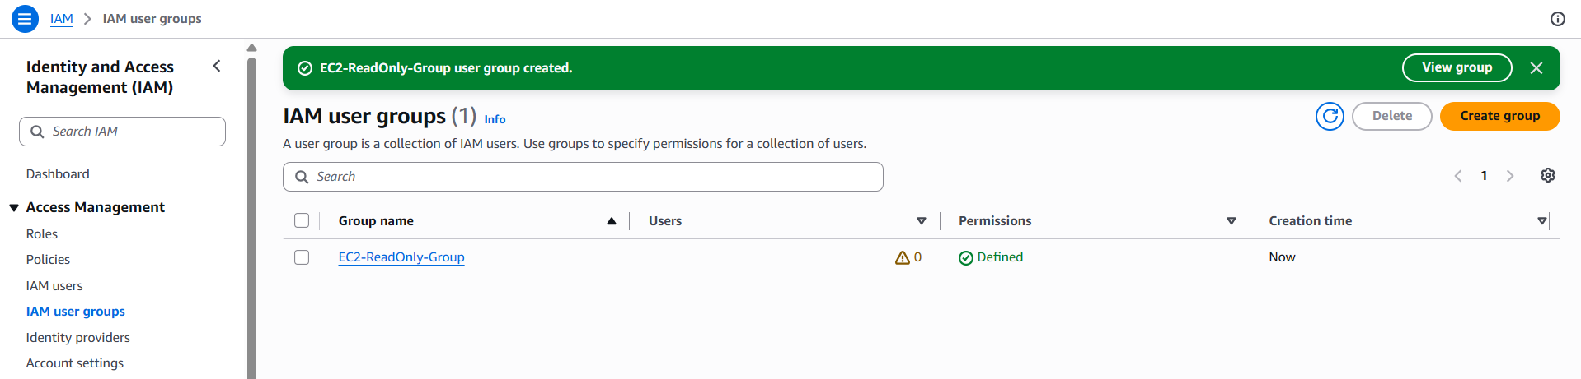

Step 2.3 — Verify
1. Left pane → User groups → click EC2-ReadOnly-Group.
2. Permissions tab → confirm AmazonEC2ReadOnlyAccess is attached.
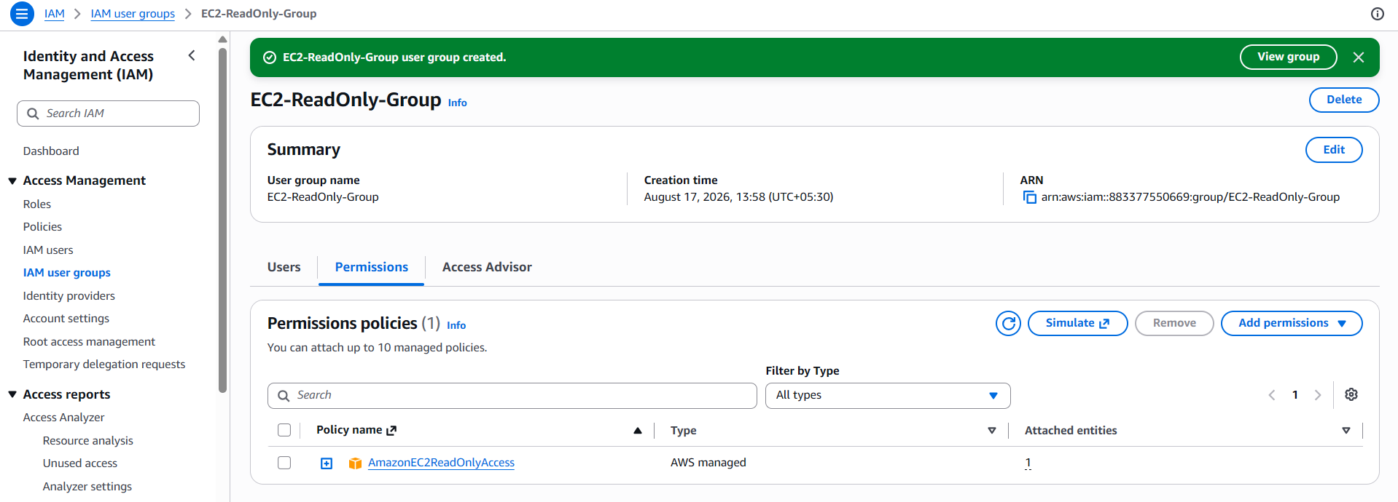
✅ Task 2 Complete: EC2-ReadOnly-Group exists with read-only EC2 permissions and no members yet.

TASK 3: Create User “Devops” and Add to the Group

Step 3.1 — Create the User
1. IAM Console → left pane → Users → Create user.
2. User name: Devops.
3. Configure console access if required, then click Next.
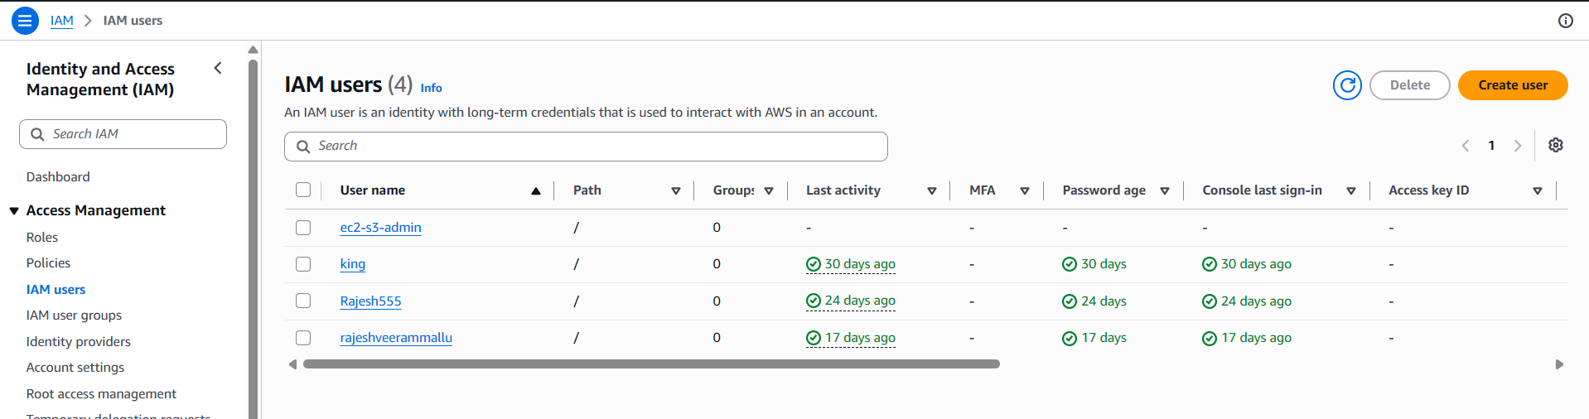
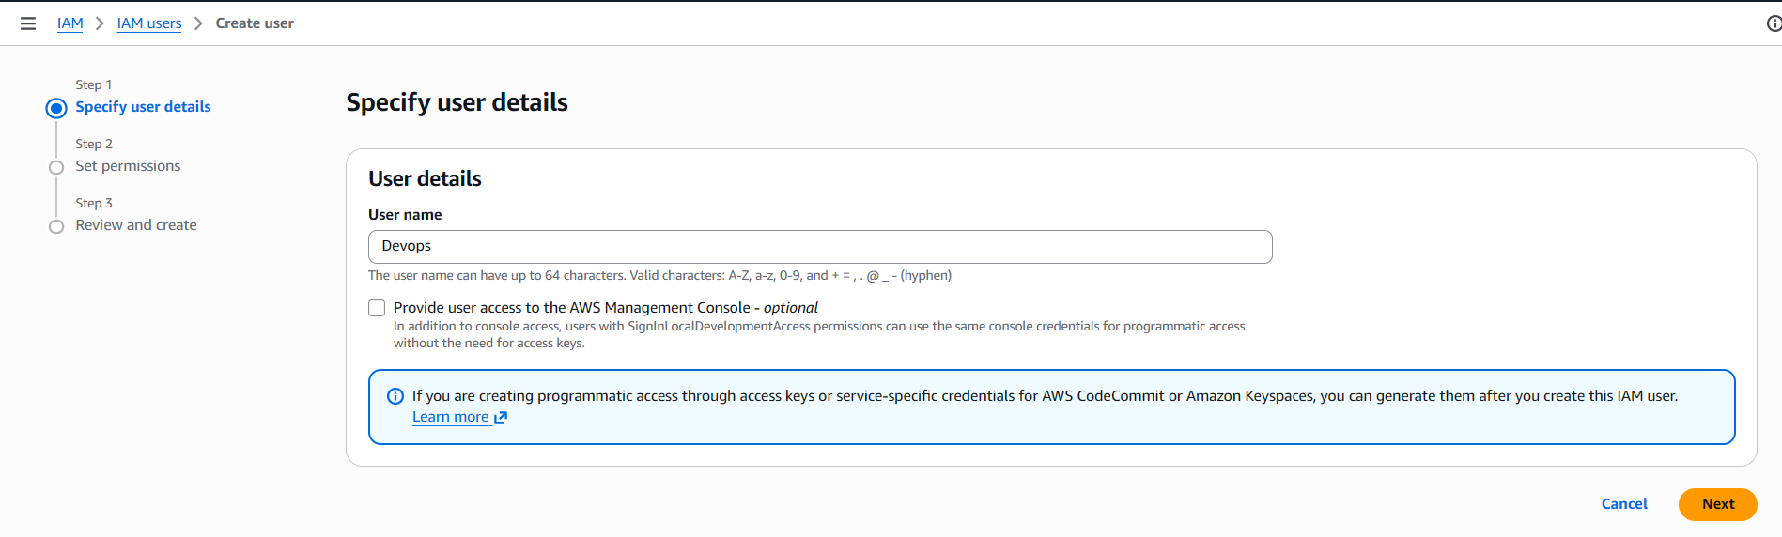

Step 3.2 — Add the User to the Group
1. On the “Set permissions” page, select Add user to group (this is the default option).
2. In the group list, check the box next to EC2-ReadOnly-Group (created in Task 2).
3. Click Next.
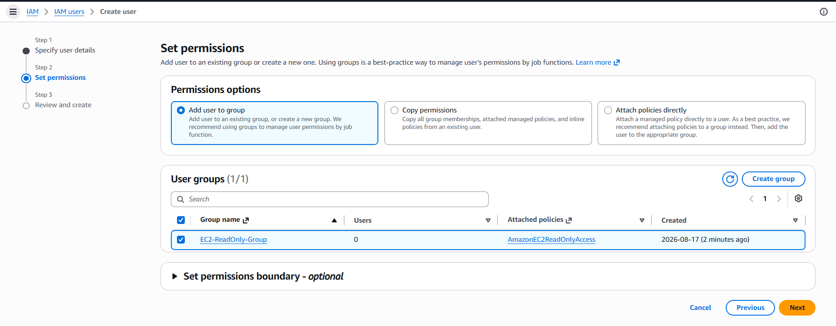

Step 3.3 — Review and Create
1. Review that Devops will be a member of EC2-ReadOnly-Group.
2. Click Create user.
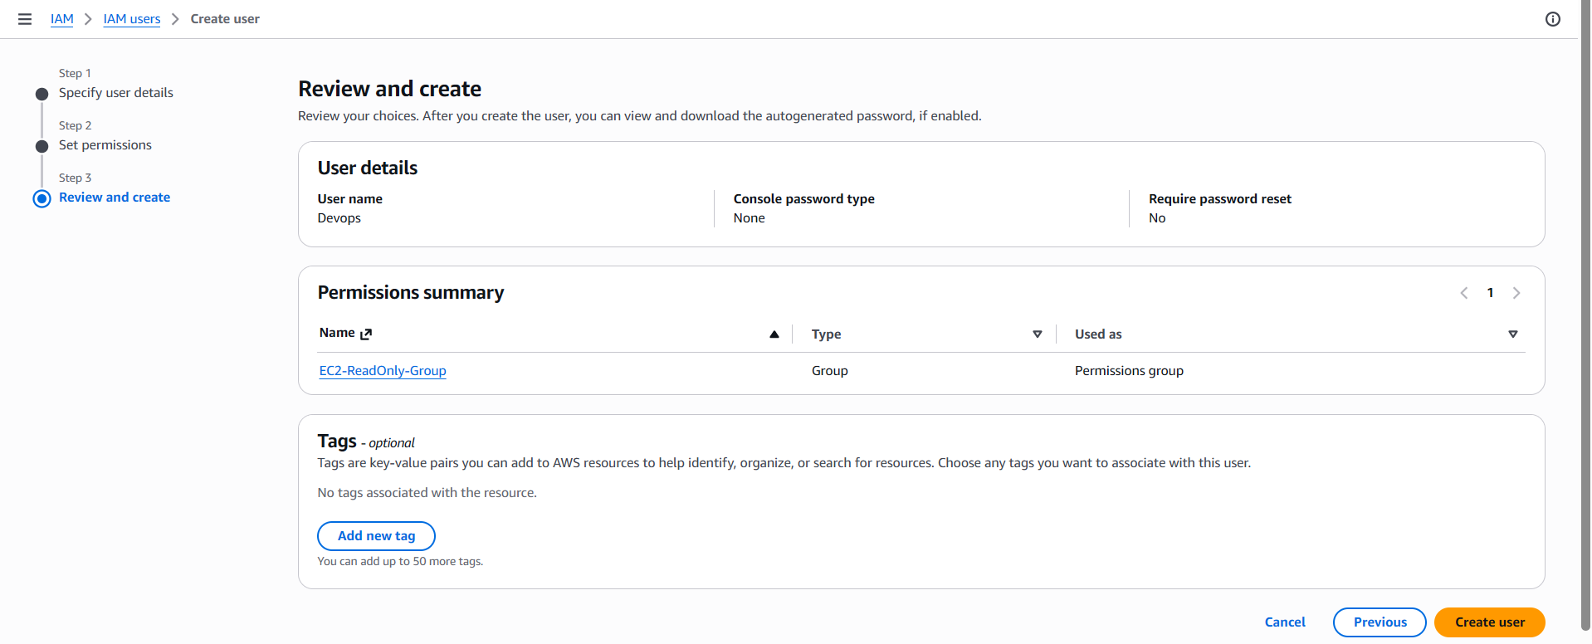

Step 3.4 — Verify
1. Left pane → Users → click Devops.
2. Groups tab → confirm EC2-ReadOnly-Group is listed.
3. Permissions tab → confirm AmazonEC2ReadOnlyAccess appears, inherited from the group (not attached directly to the user).
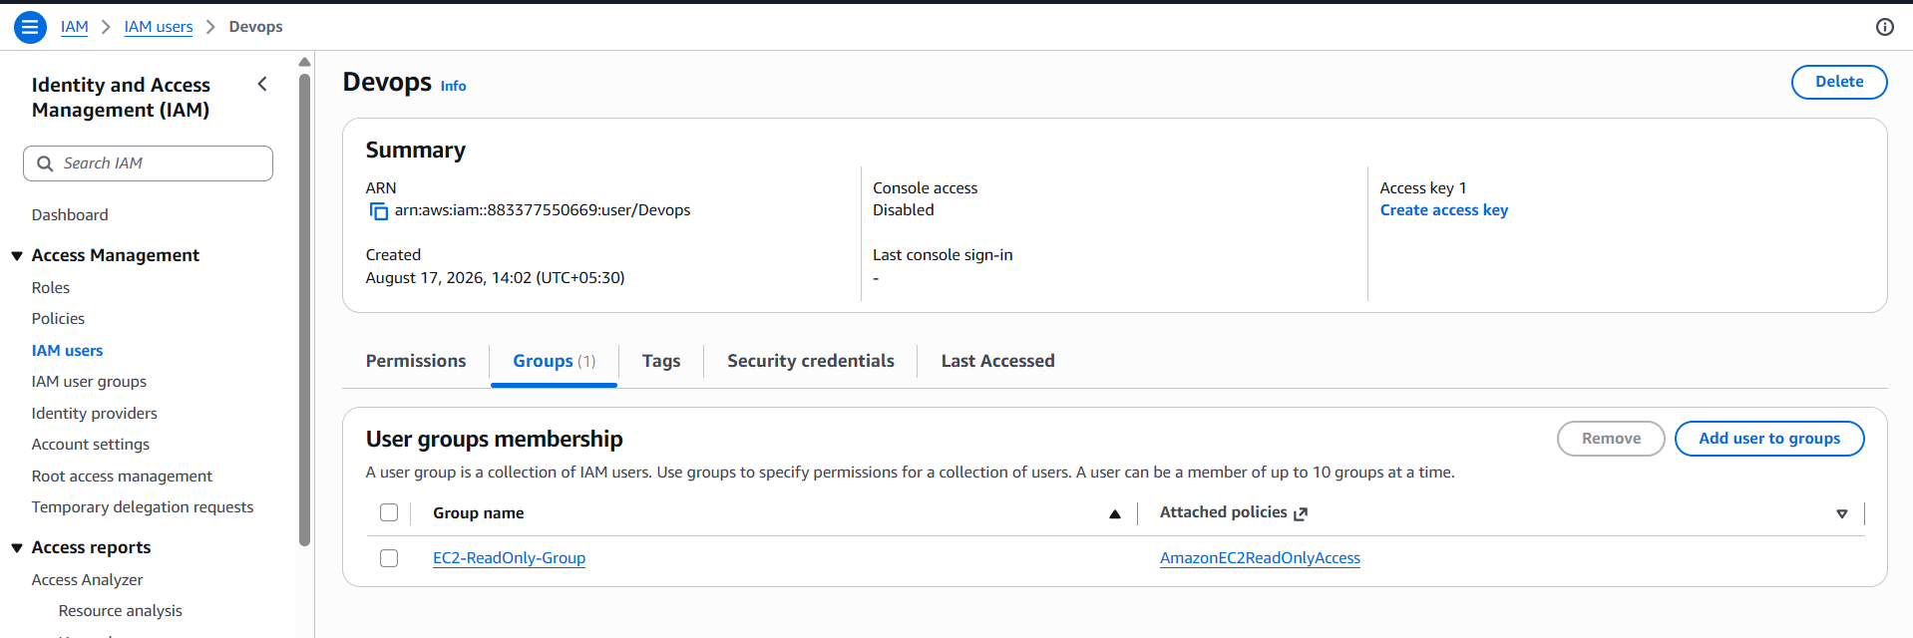
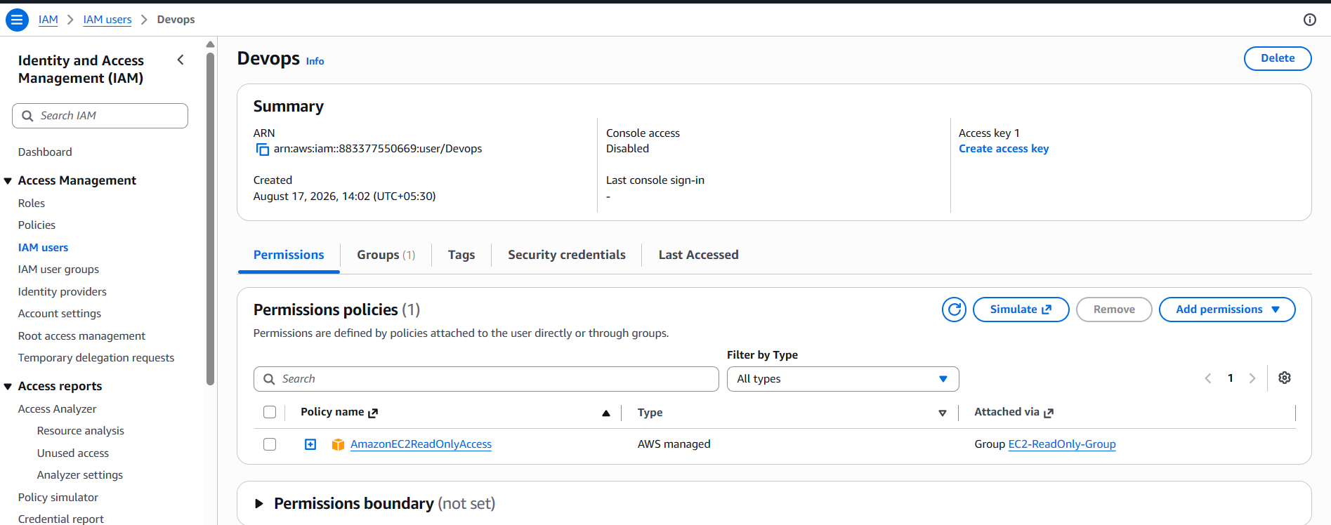
✅ Task 3 Complete: User Devops is a member of EC2-ReadOnly-Group and inherits read-only EC2 access.

TASK 4: Bash Script to Create an IAM User with VPC Full Access
This script uses the AWS CLI to create a new IAM user, attach the AWS-managed AmazonVPCFullAccess policy, and optionally generate programmatic access keys. Run it from any terminal where the AWS CLI is installed and configured with sufficient IAM permissions.

Step 4.1 — Prerequisites
1. Install the AWS CLI v2 if not already installed (aws --version to check).
2. Run aws configure and supply an Access Key ID / Secret Access Key that has IAM permissions (iam:CreateUser, iam:AttachUserPolicy, iam:CreateAccessKey).

Step 4.2 — The Script
#!/bin/bash
# create_vpc_user.sh
# Creates an IAM user and grants full VPC access.
set -euo pipefail
USER_NAME="vpc-admin-user"
POLICY_ARN="arn:aws:iam::aws:policy/AmazonVPCFullAccess"
echo "Creating IAM user: $USER_NAME"
aws iam create-user --user-name "$USER_NAME"
echo "Attaching policy: $POLICY_ARN"
aws iam attach-user-policy \
--user-name "$USER_NAME" \
--policy-arn "$POLICY_ARN"
echo "Creating programmatic access key"
aws iam create-access-key --user-name "$USER_NAME" \
> "${USER_NAME}_credentials.json"
echo "Done. Credentials saved to ${USER_NAME}_credentials.json"
echo "IMPORTANT: store this file securely and delete it from disk once copied to a vault."

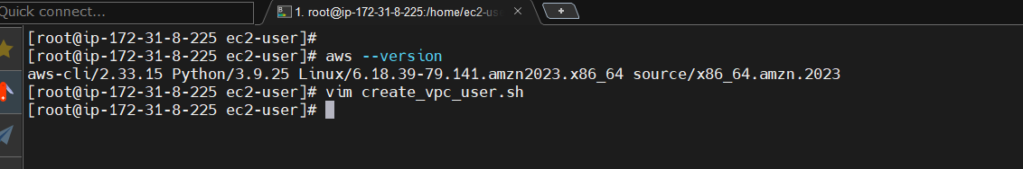

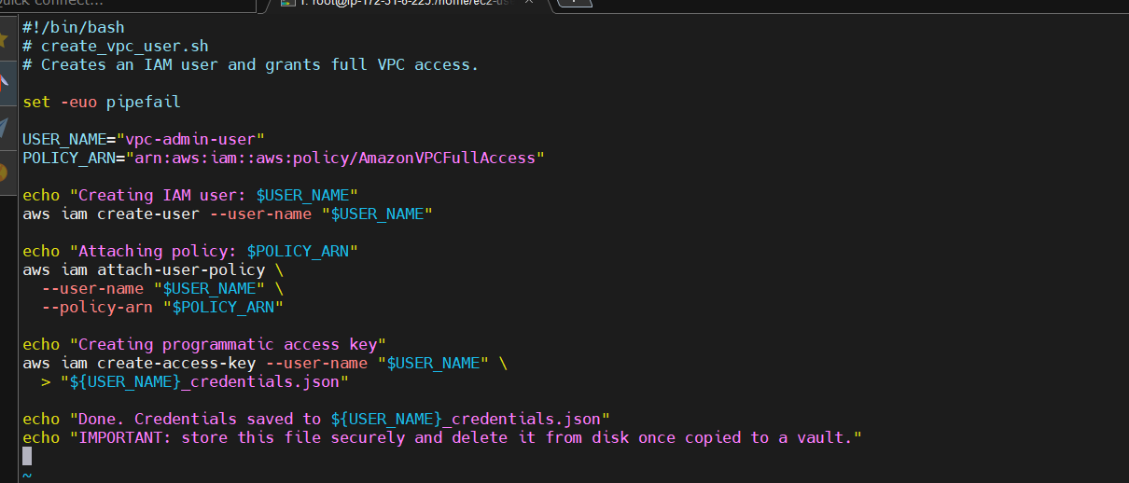

Step 4.3 — Execution Process
1. Save the script above as create_vpc_user.sh.
2. Make it executable: chmod +x create_vpc_user.sh
3. Run it: ./create_vpc_user.sh
4. Expected terminal output (values will vary):
Creating IAM user: vpc-admin-user
{
"User": {
"UserName": "vpc-admin-user",
"UserId": "AIDAEXAMPLE123456",
"Arn": "arn:aws:iam::111122223333:user/vpc-admin-user",
"CreateDate": "2026-08-17T10:15:00Z"
}
}
Attaching policy: arn:aws:iam::aws:policy/AmazonVPCFullAccess
Creating programmatic access key
Done. Credentials saved to vpc-admin-user_credentials.json

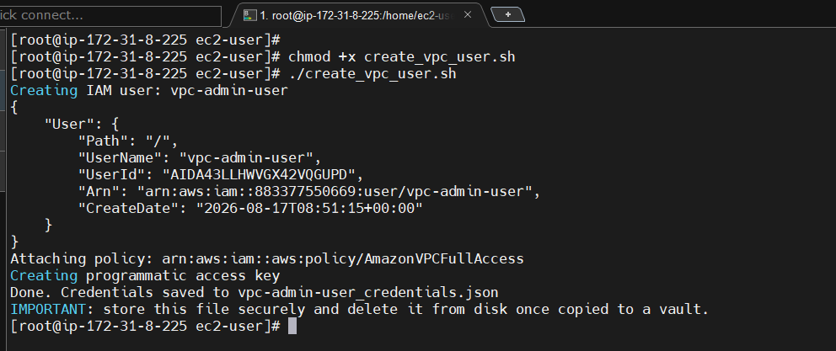

Step 4.4 — Verify in the Console
1. IAM Console → Users → click vpc-admin-user.
2. Permissions tab → confirm AmazonVPCFullAccess is attached.
3. Security credentials tab → confirm one Access key is listed as Active.
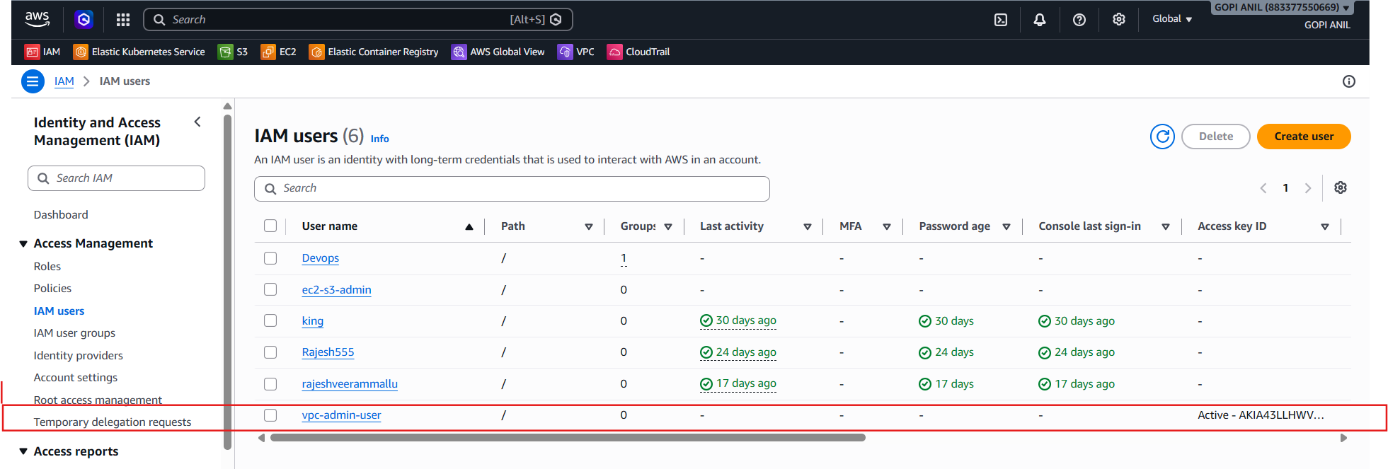
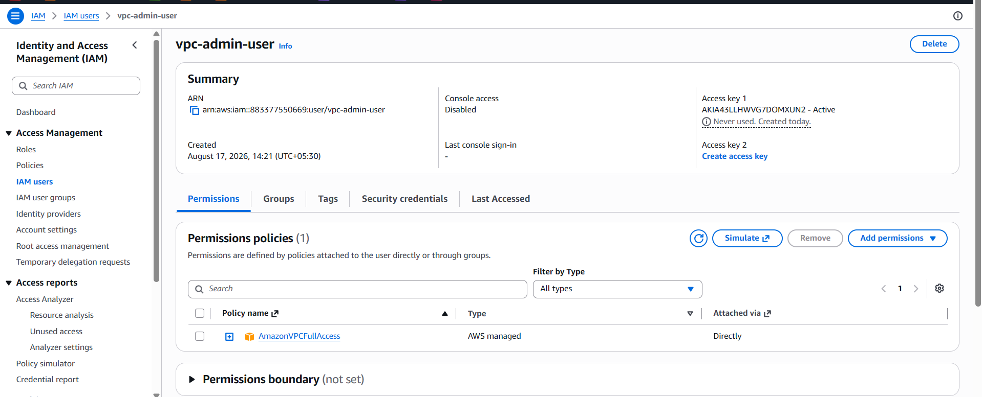
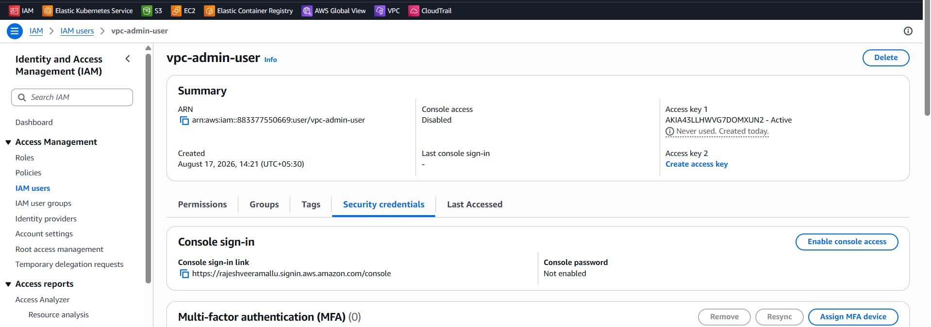
✅ Task 4 Complete: The script creates vpc-admin-user, attaches AmazonVPCFullAccess, and issues an access key — fully scriptable and repeatable.

TASK 5: IAM Policy — EC2 Access for a Specific User, Specific Regions Only
This restricts EC2 permissions to only two Regions (ap-south-1 and us-east-1 in this example) using the aws:RequestedRegion condition key, and is attached to a single named user.

Step 5.1 — Create the Custom Policy
- IAM Console → left pane → Policies → Create policy.
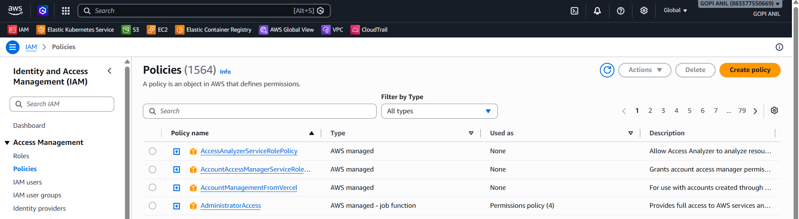
2. Select the JSON tab and replace the default content with the policy below.
{
"Version": "2012-10-17",
"Statement": [
{
"Sid": "AllowEC2InApprovedRegionsOnly",
"Effect": "Allow",
"Action": "ec2:*",
"Resource": "*",
"Condition": {
"StringEquals": {
"aws:RequestedRegion": [
"ap-south-1",
"us-east-1"
]
}
}
}
]
}
- Click Next.
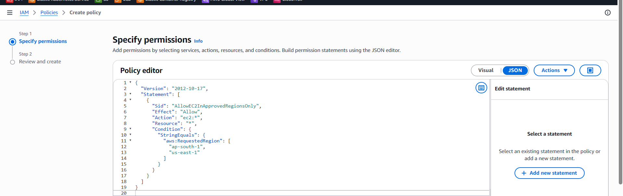
4. Policy name: EC2-Access-Restricted-Regions.
5. Description: Allows full EC2 access only in ap-south-1 and us-east-1.
6. Click Create policy.
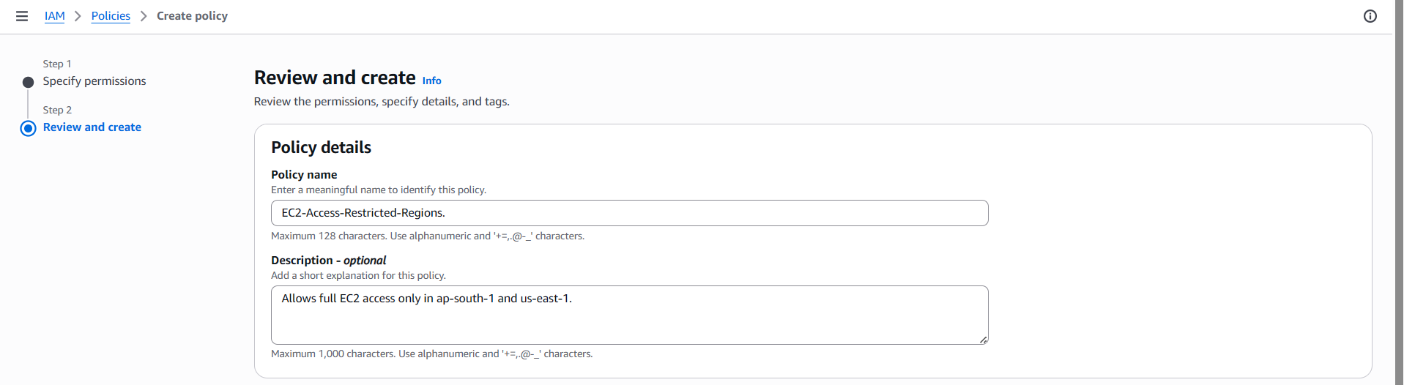
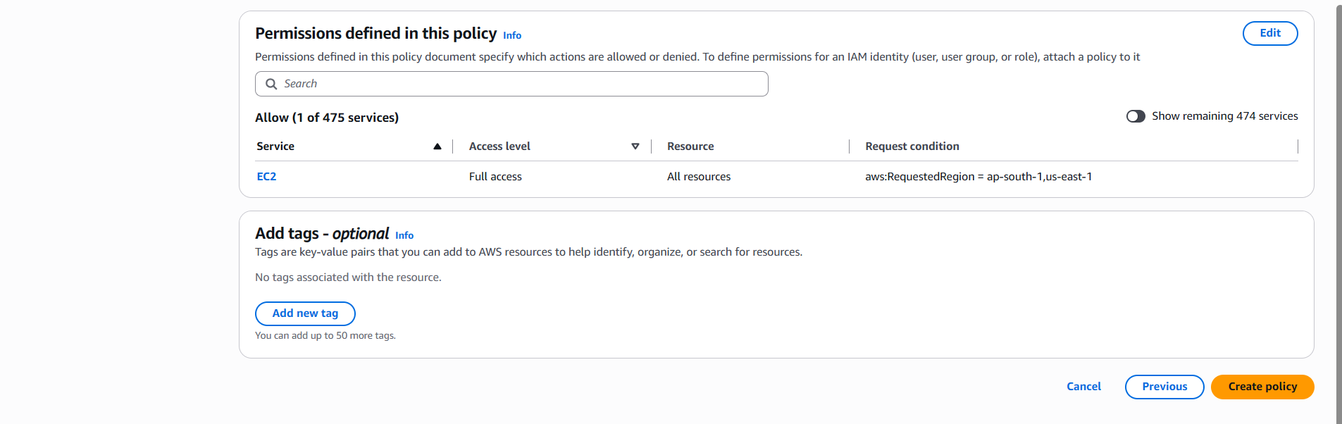

Step 5.2 — Attach the Policy to a Specific User
1. Left pane → Users → click the target user (e.g., ec2-s3-admin, or any specific user this restriction applies to).
2. Permissions tab → Add permissions → Attach policies directly.
3. Search for EC2-Access-Restricted-Regions → check the box → Next → Add permissions.
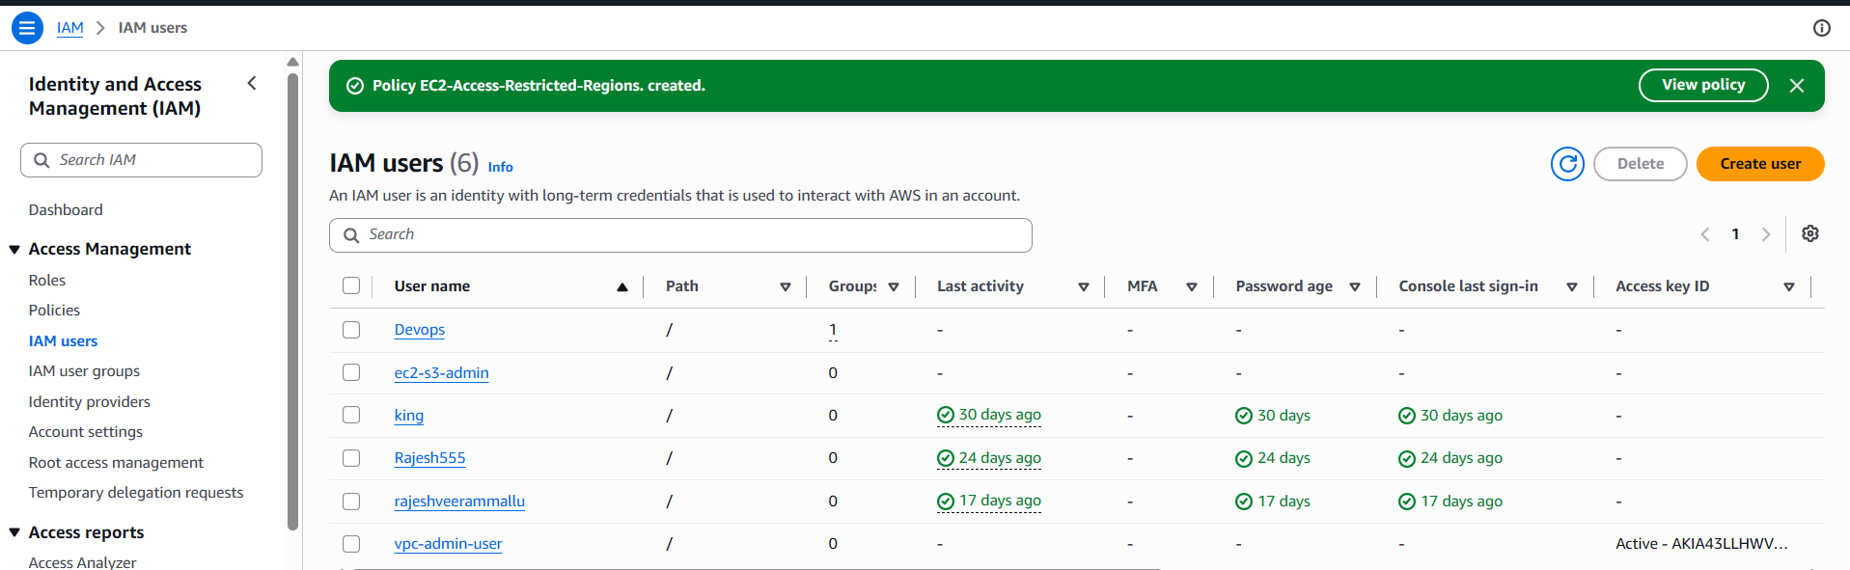
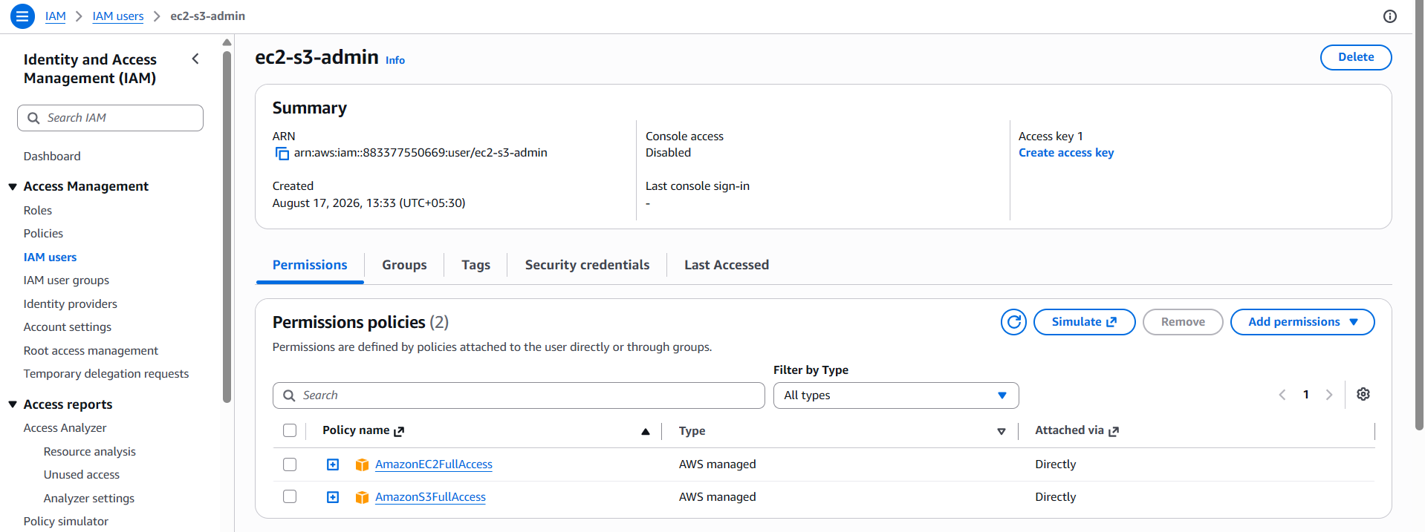
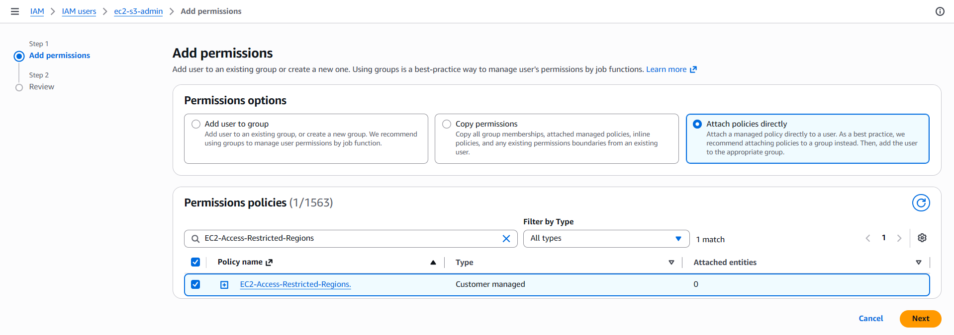
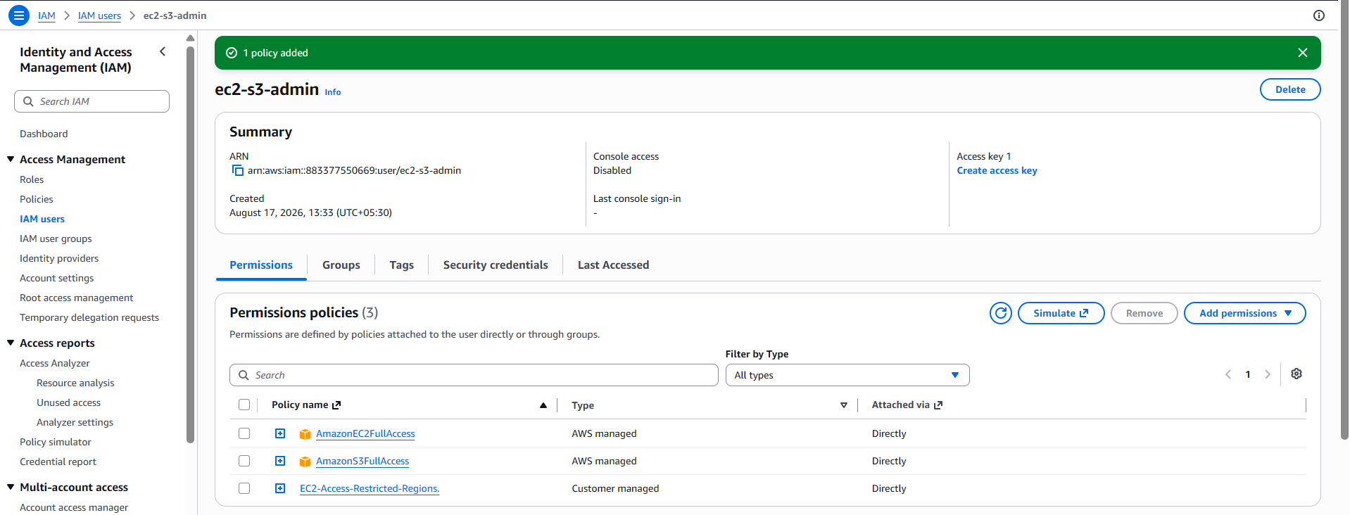

.

TASK 6: Cross-Account S3 Access — Account A User Accessing a Bucket in Account B
Goal: An IAM user in Account A (111111111111) reads/writes objects in an S3 bucket named shared-data-bucket owned by Account B (222222222222). This needs permissions granted on BOTH sides — an identity-based policy in Account A, and a resource-based bucket policy in Account B.

Step 6.1 — (Account B) Confirm/Create the S3 Bucket
1. Log in to Account B's AWS Console → S3 → Create bucket (skip if it already exists).
2. Bucket name: shared-data-bucket (must be globally unique — adjust as needed).
3. Region: choose as appropriate, e.g., ap-south-1. Leave Block all public access ON (this is a private cross-account share, not a public one).
4. Click Create bucket.
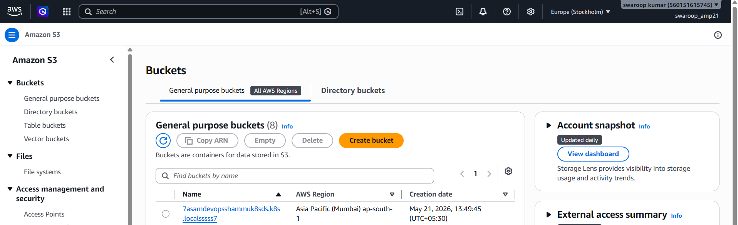
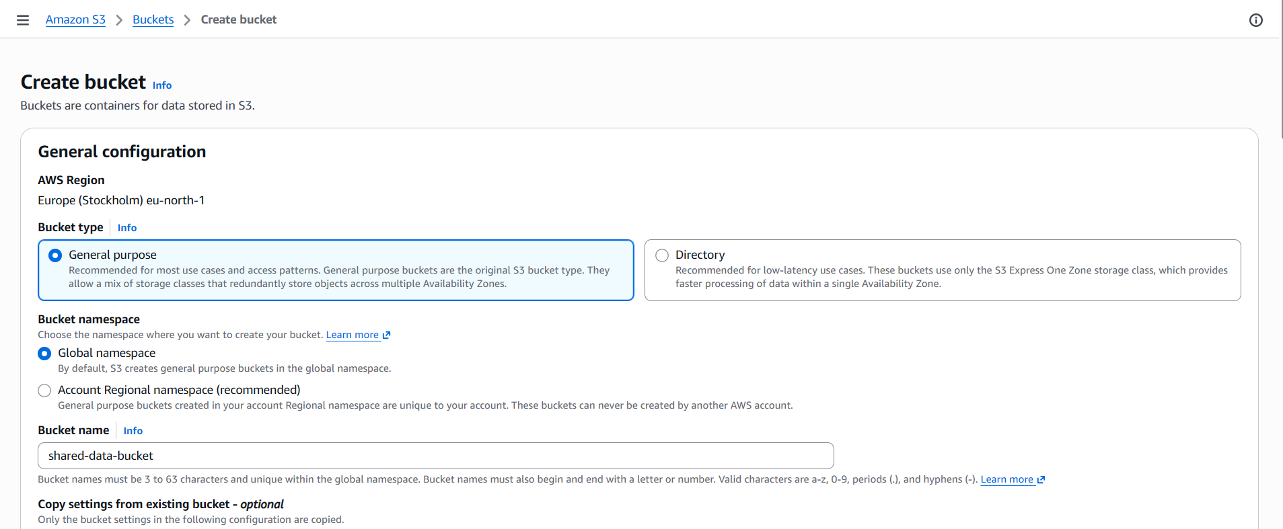
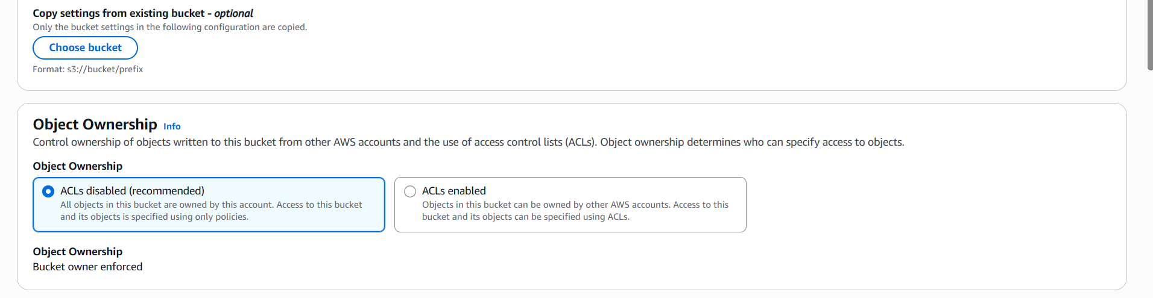
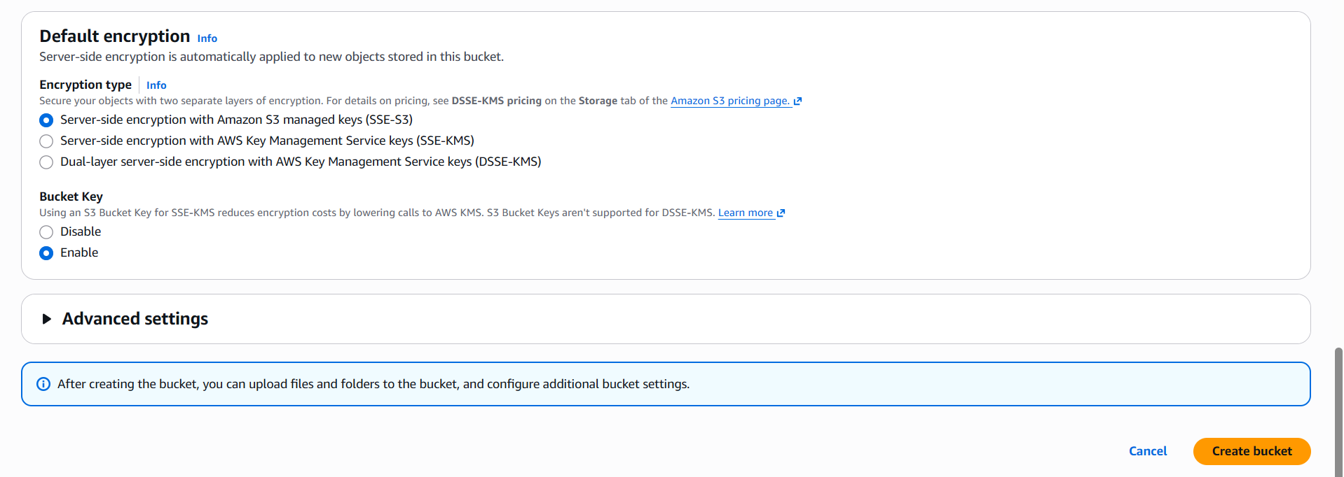
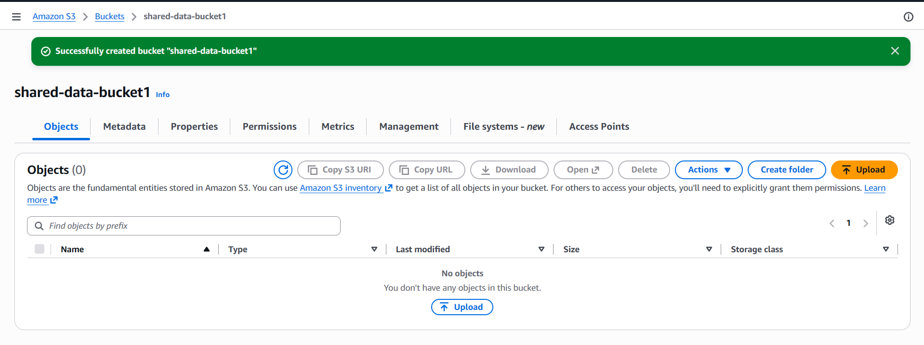

Step 6.2 — (Account B) Attach a Bucket Policy Granting Account A Access
1. Select shared-data-bucket → Permissions tab → Bucket policy → Edit.
2. Paste the policy below, replacing 111111111111 with Account A's actual account ID (or a specific user/role ARN for tighter scope).
{
"Version": "2012-10-17",
"Statement": [
{
"Sid": "AllowAccountAAccess",
"Effect": "Allow",
"Principal": {
"AWS": "arn:aws:iam::111111111111:user/cross-account-user"
},
"Action": [
"s3:GetObject",
"s3:PutObject",
"s3:ListBucket"
],
"Resource": [
"arn:aws:s3:::shared-data-bucket",
"arn:aws:s3:::shared-data-bucket/*"
]
}
]
}
- Click Save changes.
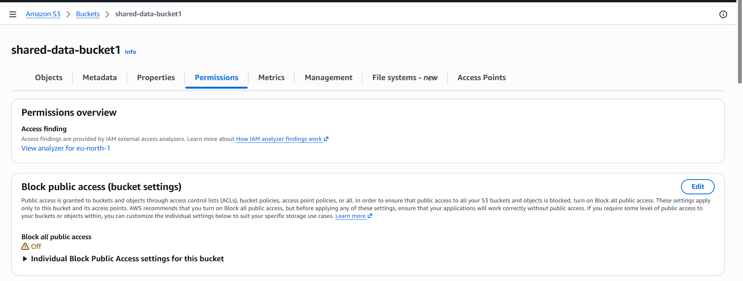
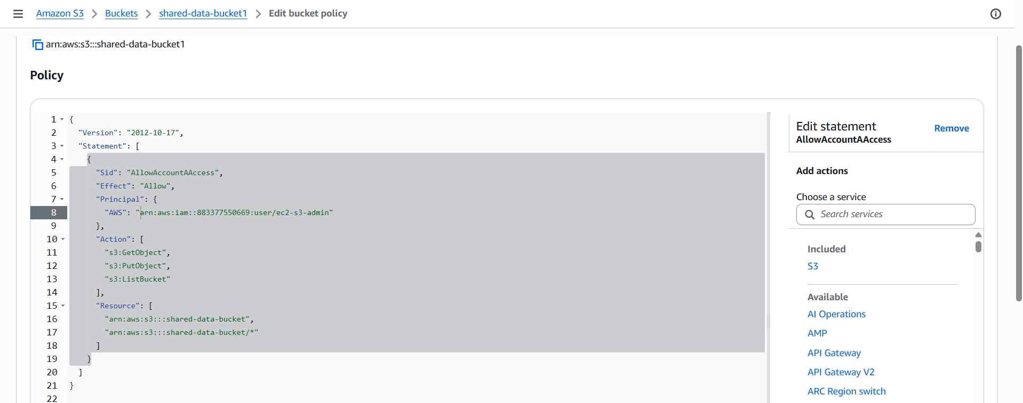
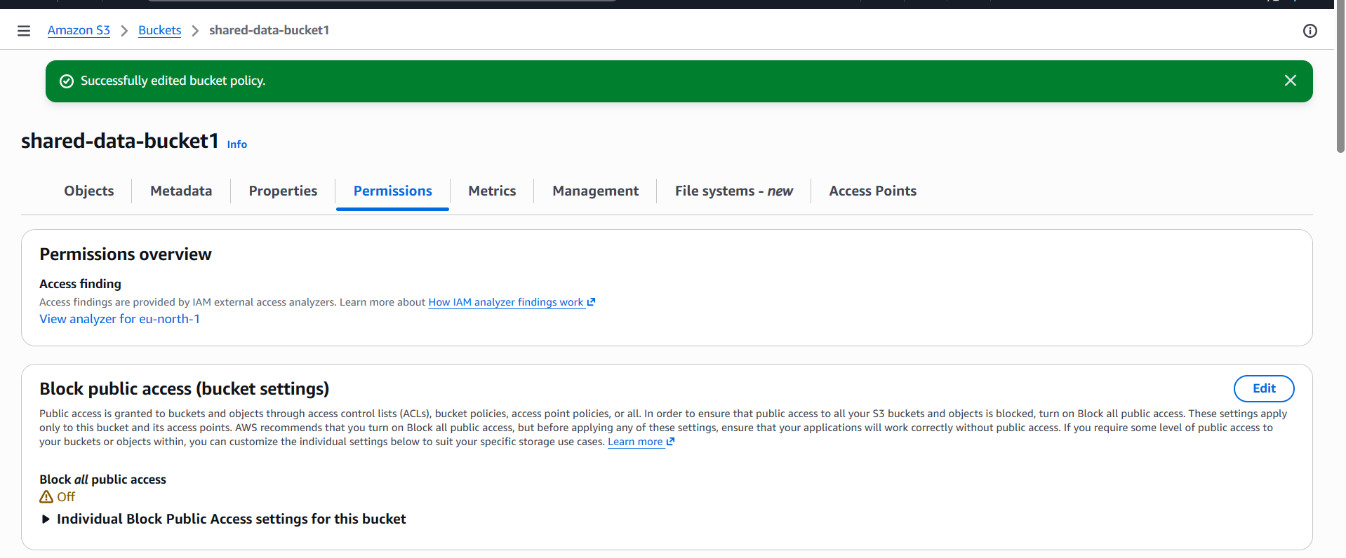

Step 6.3 — (Account A) Create/Identify the User
1. Log in to Account A's AWS Console → IAM → Users.
2. Use an existing user or create a new one named cross-account-user (Users → Create user → name it → Next → Create user), matching the ARN used in the bucket policy above.

Step 6.4 — (Account A) Attach an Identity-Based Policy Granting Access to Account B's Bucket
1. IAM Console → Policies → Create policy → JSON tab.
{
"Version": "2012-10-17",
"Statement": [
{
"Sid": "AllowAccessToAccountBBucket",
"Effect": "Allow",
"Action": [
"s3:GetObject",
"s3:PutObject",
"s3:ListBucket"
],
"Resource": [
"arn:aws:s3:::shared-data-bucket",
"arn:aws:s3:::shared-data-bucket/*"
]
}
]
}
- Click Next. Policy name: Access-AccountB-SharedBucket. Click Create policy.
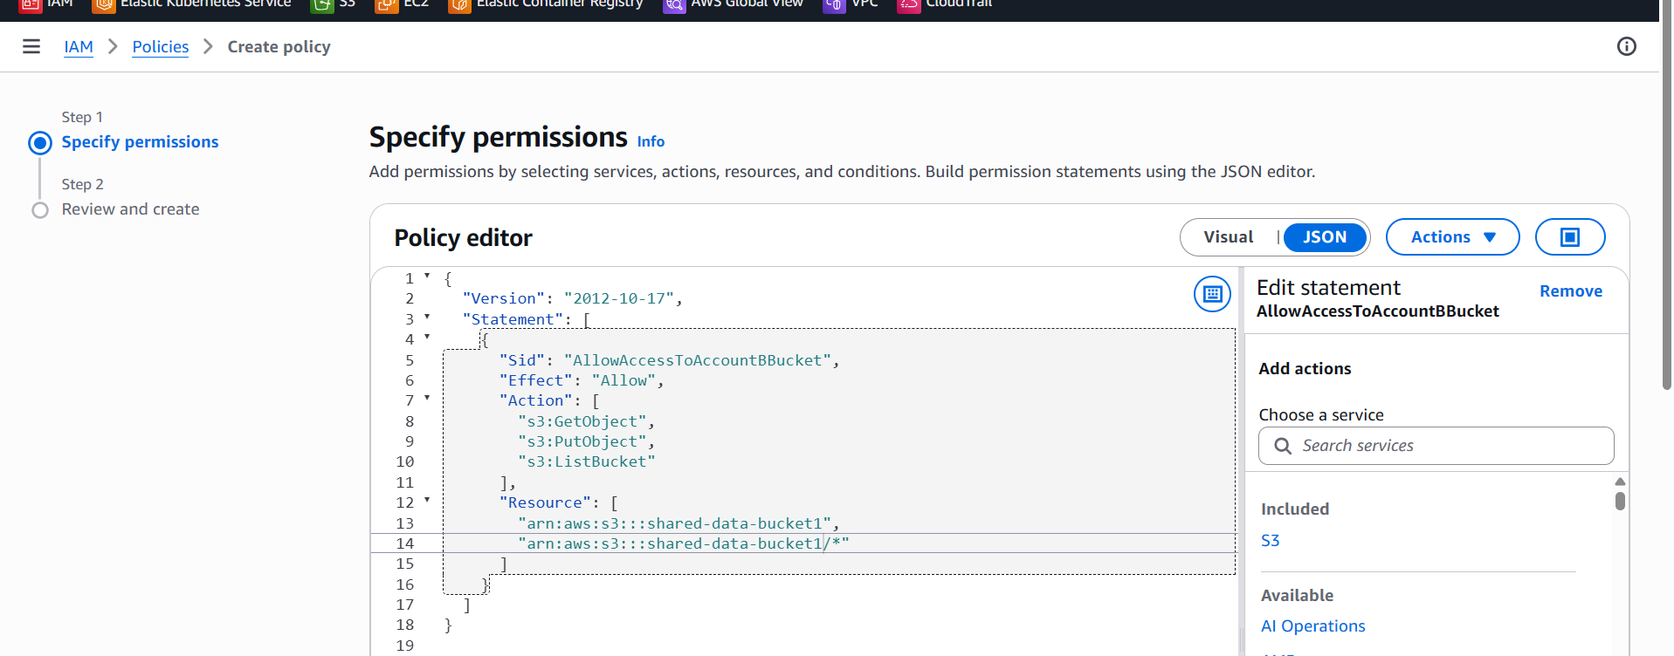
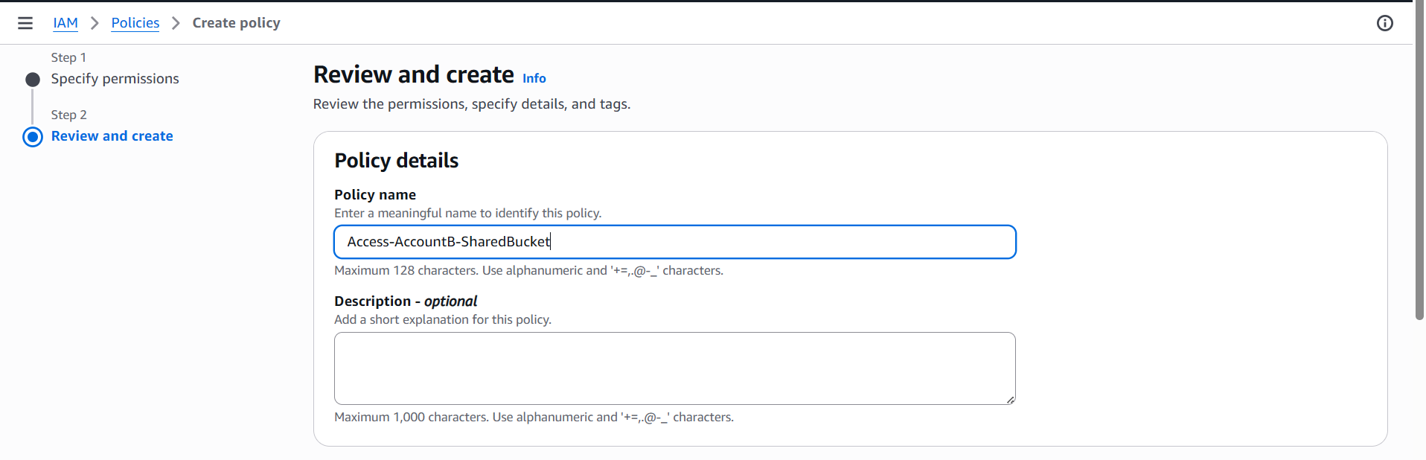
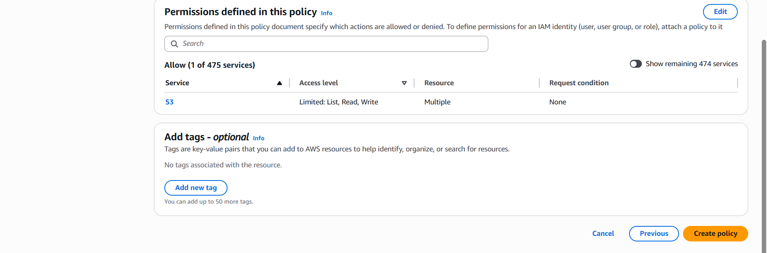
- Go to Users → cross-account-user → Permissions tab → Add permissions → Attach policies directly → search for and select Access-AccountB-SharedBucket → Add permissions.
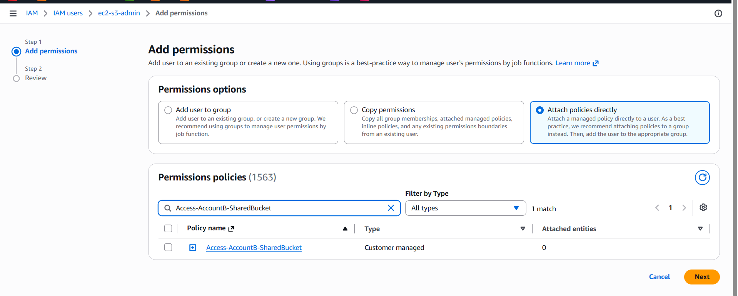

Step 6.5 — Test Cross-Account Access
1. As cross-account-user in Account A (using their access key via aws configure --profile accountA), run:
aws s3 ls s3://shared-data-bucket --profile accountA
2. A successful listing confirms both the bucket policy (Account B) and the identity policy (Account A) are correctly aligned.
3. Test an upload: aws s3 cp test.txt s3://shared-data-bucket/ --profile accountA — should succeed if s3:PutObject was granted.

